報名表APPLICATION FORM 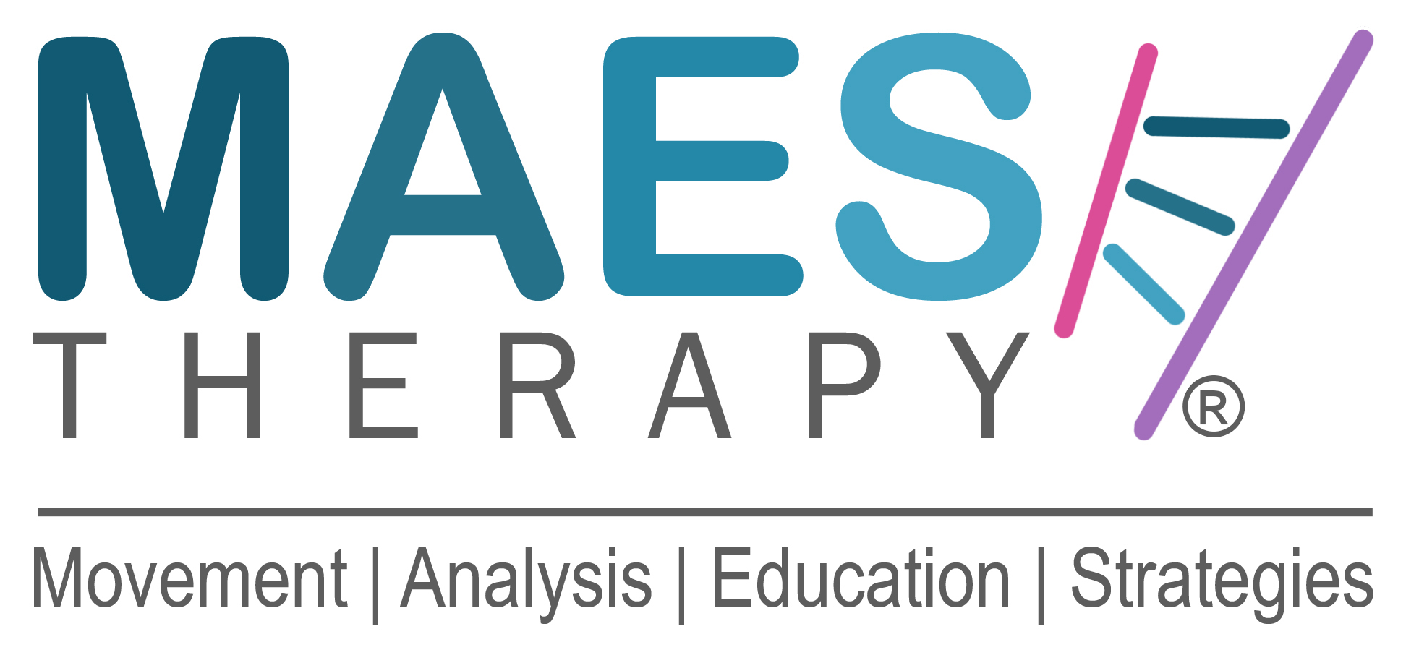

中文姓名 Original Name: 英文姓名First Name: Family Name:

職業別 Profession & Job Title (PT, OT, SLT, Doctor) :

住家地址 Full Home Address:

公司名稱 Name of Place of Work:

公司電子信箱 E-mail Work:

私人電子信箱 E-mail Private:

手機號碼Private Mobile No:

國際M.A.E.S.認證課程
針對腦性麻痺及類似神經發展疾患兒童之動作分析與教育策略
M.A.E.S. Course:
‘Movement Analysis & Education Strategies Course for children with Cerebral Palsy and similar neurodevelopmental conditions’

本課程為期四周 (20天)，分為第一及第二階段，各為期兩周。
Length of Course: 20-Days (4-Weeks) Post-graduate course in two parts of two weeks.

第一階段：2023年9月6日 (三) 至 9月17日 (日)，台灣時間下午1點至晚上9點，線上課程
Part 1: Weds. 6 September – Sun. 17 September 2023 Weeks 1 & 2 Online via Zoom
Each Day Online: Taiwan Time: 1.00 pm - 9.00 pm

第二階段：2023年9月29日 (五) 至 10月10日 (二)，早上9點至下午5點，實體課程
Part 2: Fri. 29 September – Tues. 10 October 2023 Weeks 3 & 4 Face-to Face
Each Day , Face-to-Face 09.00 am - 5.00 pm

建議在第一階段到第二階段期間，學員安排臨床工作以練習第一階段所學
It is very helpful for Participants’ learning to plan and make arrangements to use the period between Part 1 and Part 2 to try putting into practice the knowledge gained in Part 1, before returning for Part 2.

主辦單位：臺灣物理治療學會
Local Course Organiser: Taiwan Physical Therapy Association (TPTA).

第二階段課程地點：國立陽明交通大學 物理治療暨輔助科技學系
台北市北投區立農街二段155號 生醫工程館六樓 (詳細教室地點待公布)
Venue for Part 2: (Exact room location awaits for confirmation)
Department of Physical Therapy and Assistive Technology
National Yang Ming Chiao Tung University
No. 155, Sec. 2, Linong St., Beitou Dist., Taipei City 112304, Taiwan

學員報名資格：
學員須為兒童治療師 (物理治療師、職能治療師、語言治療師)或醫師 (小兒科醫師、小兒神經科醫師、兒童復健科醫師)，且至少有兩年治療腦性麻痺及類似神經發展疾患兒童的臨床執業經驗。本繼續教育課程不僅適合初次針對腦性麻痺主題進修的治療師與醫師，也適合已認證國際課程的資深治療師。
Course Participants Criteria:

Participants must be fully qualified Paediatric Therapists (Physiotherapists, Occupational Therapists, Speech Therapists) or medical Doctors (paediatricians, neurologists, PM&R), with at least two years’ experience in treating children with Cerebral Palsy and similar neurological conditions. The course will appeal to therapists who are about to take their first postgraduate course in the field of Cerebral Palsy and equally as well as to very experienced therapists who have already taken several specialist courses.

課程講師：
Jean-Pierre Maes MCSP，神經發展物理治療顧問，M.A.E.S. Therapy International創辦人暨總監
Course Leader:
Jean-Pierre Maes MCSP Consultant Neurodevelopmental Physiotherapist,
Founder & Director M.A.E.S. Therapy International

課程費用：
於2023年4月18日前報名，物理治療學會會員110,000元台幣，非會員115,000元台幣
於2023年4月19日後報名，物理治療學會會員112,500元台幣，非會員117,500元台幣

Course Fee:
For TPTA member paid before 18 April 2023, the course fee is 110,000 TWD, for non member 115,000 TWD
For TPTA member paid after 19 April 2023, the course fee is 112,500 TWD, for non member 117,500 TWD

保險聲明 Insurance statement:

“通過提交此報名表，我確認我是此文件上的本人，且是有治療師職業責任保險的本人”。
“By submitting this Application Form, I confirm that I am the person named on this form and I will be covered by my own Professional Liability Insurance if I attend this course”.

姓名Full Name ( Print your name ) :-

_________________________________________________________________________
報名程序
Application:

- 請完成此報名表，連同履歷email至
課程承辦人：蕭茗榕物理治療師 siaomingrong@gmail.com

To apply for a place on the course, please complete this Application Form
and together with your CV, e-mail to:

TPTA Contact for this course: Ming-Rong Siao, Physiotherapist
E: siaomingrong@gmail.com

- 履歷
請將完整的履歷包含臨床工作經驗附件於報名email
C.V.
Please also attach your full Curriculum Vitae, including your full professional work experience.

- 付款
在講師審核報名表及履歷後，承辦人將email提供繳費方式
How to Pay:
Once this Application Form and accompanying CV have been submitted and accepted, details about how to make the payments will be provided.

- 報名確認
在主辦單位確認學費付清後，學員將收到承辦人email確認報名成功
Confirmation:
Upon receipt of the full Course Fee, you will receive an email confirming your Registration and place on the course ( subject to receipt of full payment by the deadline date).

M.A.E.S. Movement Analysis Education Strategies Therapy

